Taylor Cowley

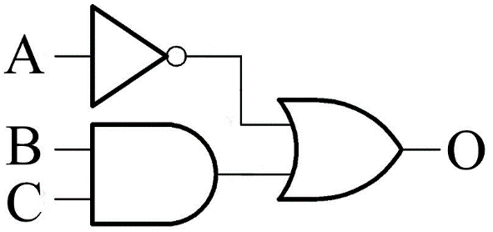220 Lab 00 Introduction

April 28 2016

1. Make a new document
2. Use it as a scratch pad
3. See the picture? What is the logic equation?

O = A’ + (B*C)

1. Put the image in the lab report
2. Make a truth table with 3 inputs
3. Copy the following equation on a piece of paper

|  |  |  |  |
| --- | --- | --- | --- |
| A | B | C | O |
| 0 | 0 | 0 | 1 |
| 0 | 0 | 1 | 1 |
| 0 | 1 | 0 | 1 |
| 0 | 1 | 1 | 1 |
| 1 | 0 | 0 | 0 |
| 1 | 0 | 1 | 0 |
| 1 | 1 | 0 | 0 |
| 1 | 1 | 1 | 1 |

1. F = ((AB)'+(AB)')'•((CD)'+(CD)')
2. Now draw the circuit
3. Now simplify the circuit and draw that
4. Now scan the image
5. Now insert the scanned image into the document
6. Save often
7. Submit the lab document on Learning Suite as a PDF